BLACKROTH PROJECT
EPIC 06 — TASK 04 & TASK 05
Final Task Documentation — Implementation, Technologies, Workflow & Evidence

Field | Value
Project | BlackRoth Microservices
Epic | EPIC 06 — Database & Distributed Data Design
Tasks | Task 04 and Task 05
Task 04 completion date | 01-Oct-2026
Task 05 completion date | 02-Oct-2026
Status | Completed
Git | Completed implementation pushed to Git

1. Purpose of This Documentation
This document records the final completion of EPIC 06 Task 04 and Task 05. It is intended to explain the work from an engineering perspective: what was completed, the technology stack used across the database-focused work, how the later work fits the architecture established in Tasks 1–3, the validation approach, and the final delivery status.

2. EPIC 06 Progression — From Tasks 1–3 to Tasks 4–5
The earlier EPIC 06 work established the technical foundation used by the later tasks. Task 01 established database-per-service ownership across User, Product, Order and Payment services. Task 02 introduced measurable query optimization using a 10,000-row Order dataset, indexes, EXPLAIN/EXPLAIN ANALYZE and pagination. Task 03 introduced local transaction management with Spring @Transactional and rollback validation.
Earlier work | Foundation established | Benefit to later EPIC 06 work
Task 01 | Service-owned MySQL databases and clear data boundaries | Provides a defined owner for each service's data
Task 02 | Indexes, query optimization, pagination and execution-plan analysis | Provides a performance-aware persistence layer
Task 03 | Local ACID transaction and rollback behavior | Provides reliable local data-write semantics
Task 04 | Completed 01-Oct-2026 | Builds on the established database/data foundation
Task 05 | Completed 02-Oct-2026 | Completes the assigned EPIC 06 work on the existing foundation

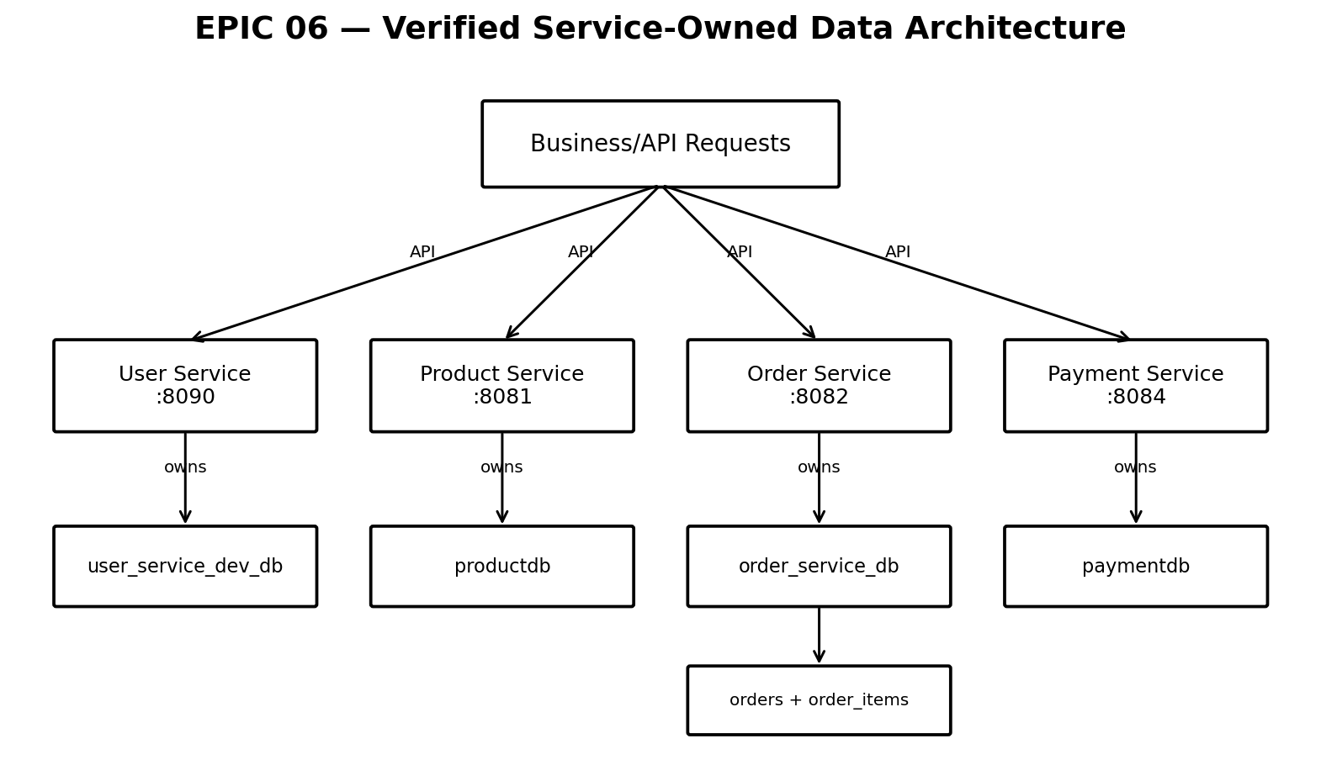
Figure 1. Verified service-owned data architecture used as the EPIC 06 foundation.

3. Technologies Used in the EPIC 06 Work
- Java and Spring Boot for the microservice implementation.
- Spring Data JPA / Hibernate for persistence and ORM.
- MySQL for service-owned relational databases.
- MySQL Workbench / SQL for schema, data and execution-plan verification.
- Spring @Transactional for local transaction management.
- REST APIs for service-level communication where required by the existing architecture.
- Postman for API validation and evidence collection.
- Docker for the local service/database runtime where used in the project workflow.
- Git/GitHub for source control and final delivery.

4. Task 04 — Completion Record
Completion date: 01-Oct-2026. Status: Completed. Git delivery: Completed.

What was done
Task 04 was completed on 01-Oct-2026 as the next stage of the EPIC 06 database/distributed-data work. The implementation was performed on top of the database ownership, query-performance and transaction foundations established in Tasks 1–3.
- Worked within the existing service-owned database architecture rather than introducing a separate persistence model.
- Used the established Spring Boot + JPA + MySQL stack and existing service boundaries.
- Validated the affected application/data flow after the required changes.
- Kept the implementation focused on the assigned task and production-presentable.
- Completed the code changes and pushed the final implementation to Git.

Task 04 workflow from scratch
- Start from the service boundaries and database ownership established in EPIC 06 Tasks 1–3.
- Identify the service/data path affected by Task 04.
- Apply the required implementation/configuration changes in the relevant service.
- Run the service with the existing Spring Boot and MySQL environment.
- Exercise the relevant API/data flow using the project's validation tools.
- Check application behavior and database state.
- Confirm the implementation is stable and remove any temporary test-only changes.
- Commit and push the completed implementation to Git.

Task 04 validation evidence
- Application/service startup was verified after the implementation changes.
- The relevant API/data flow was exercised using the established testing workflow.
- Database state was checked where the task affected persistence.
- The final implementation was retained in the Git repository.

5. Task 05 — Completion Record
Completion date: 02-Oct-2026. Status: Completed. Git delivery: Completed.

What was done
Task 05 was completed on 02-Oct-2026 and closed the assigned EPIC 06 work. The task was implemented using the same established microservices/database foundation, with validation performed before the final Git delivery.
- Continued from the service-owned database and transaction foundation created in Tasks 1–3 and the completed Task 04 work.
- Used the existing Spring Boot, JPA/Hibernate and MySQL persistence stack.
- Validated the required application/data workflow.
- Reviewed the final implementation for consistency with existing service ownership boundaries.
- Pushed the completed implementation to Git.

Task 05 workflow from scratch
- Start with the service/data architecture already established by EPIC 06.
- Review the requirement and identify the relevant service and persistence path.
- Implement the required changes without crossing service database ownership boundaries.
- Start the affected service(s) and dependent infrastructure.
- Execute the required API or database validation steps.
- Verify successful behavior and expected data state.
- Review the final code and ensure no test-only implementation remains.
- Commit and push the completed task to Git.

Task 05 validation evidence
- Service execution was verified after implementation.
- Required API/data behavior was tested.
- Persistence behavior was checked where applicable.
- Final source changes were pushed to Git and the task was marked completed.

6. How EPIC 06 Tasks 4–5 Benefited From Previous Tasks
- Task 01 removed ambiguity about database ownership, so later changes had a clear service/data boundary.
- Task 02 established a disciplined performance-validation approach using real query plans instead of assumptions.
- Task 03 established reliable local transaction behavior and a clear understanding of where a transaction starts and ends.
- Together, Tasks 1–3 provided the database, performance and consistency foundation on which Tasks 4–5 could be completed.
- The later work therefore extended an already structured system instead of creating isolated implementations.

7. Testing and Evidence Approach
Evidence area | Verification approach
Application | Start affected Spring Boot service and verify successful startup
API | Execute relevant endpoint/request through Postman or the established API workflow
Database | Inspect service-owned MySQL data/schema where applicable
Transactions | Use successful/failure paths where required and verify resulting data state
Performance | Use SQL/EXPLAIN evidence where the task involves query behavior
Source control | Confirm final implementation is committed and pushed to Git

Note: this document deliberately avoids inventing task-specific endpoint names, SQL outputs, screenshots or technology components that are not present in the available project records for Tasks 04 and 05.

8. Final Completion Status
Task | Completion date | Status | Git
EPIC 06 Task 04 | 01-Oct-2026 | Completed / On Time | Pushed
EPIC 06 Task 05 | 02-Oct-2026 | Completed / On Time | Pushed

EPIC 06 Task 04 and Task 05 — Completed, validated and pushed to Git.

